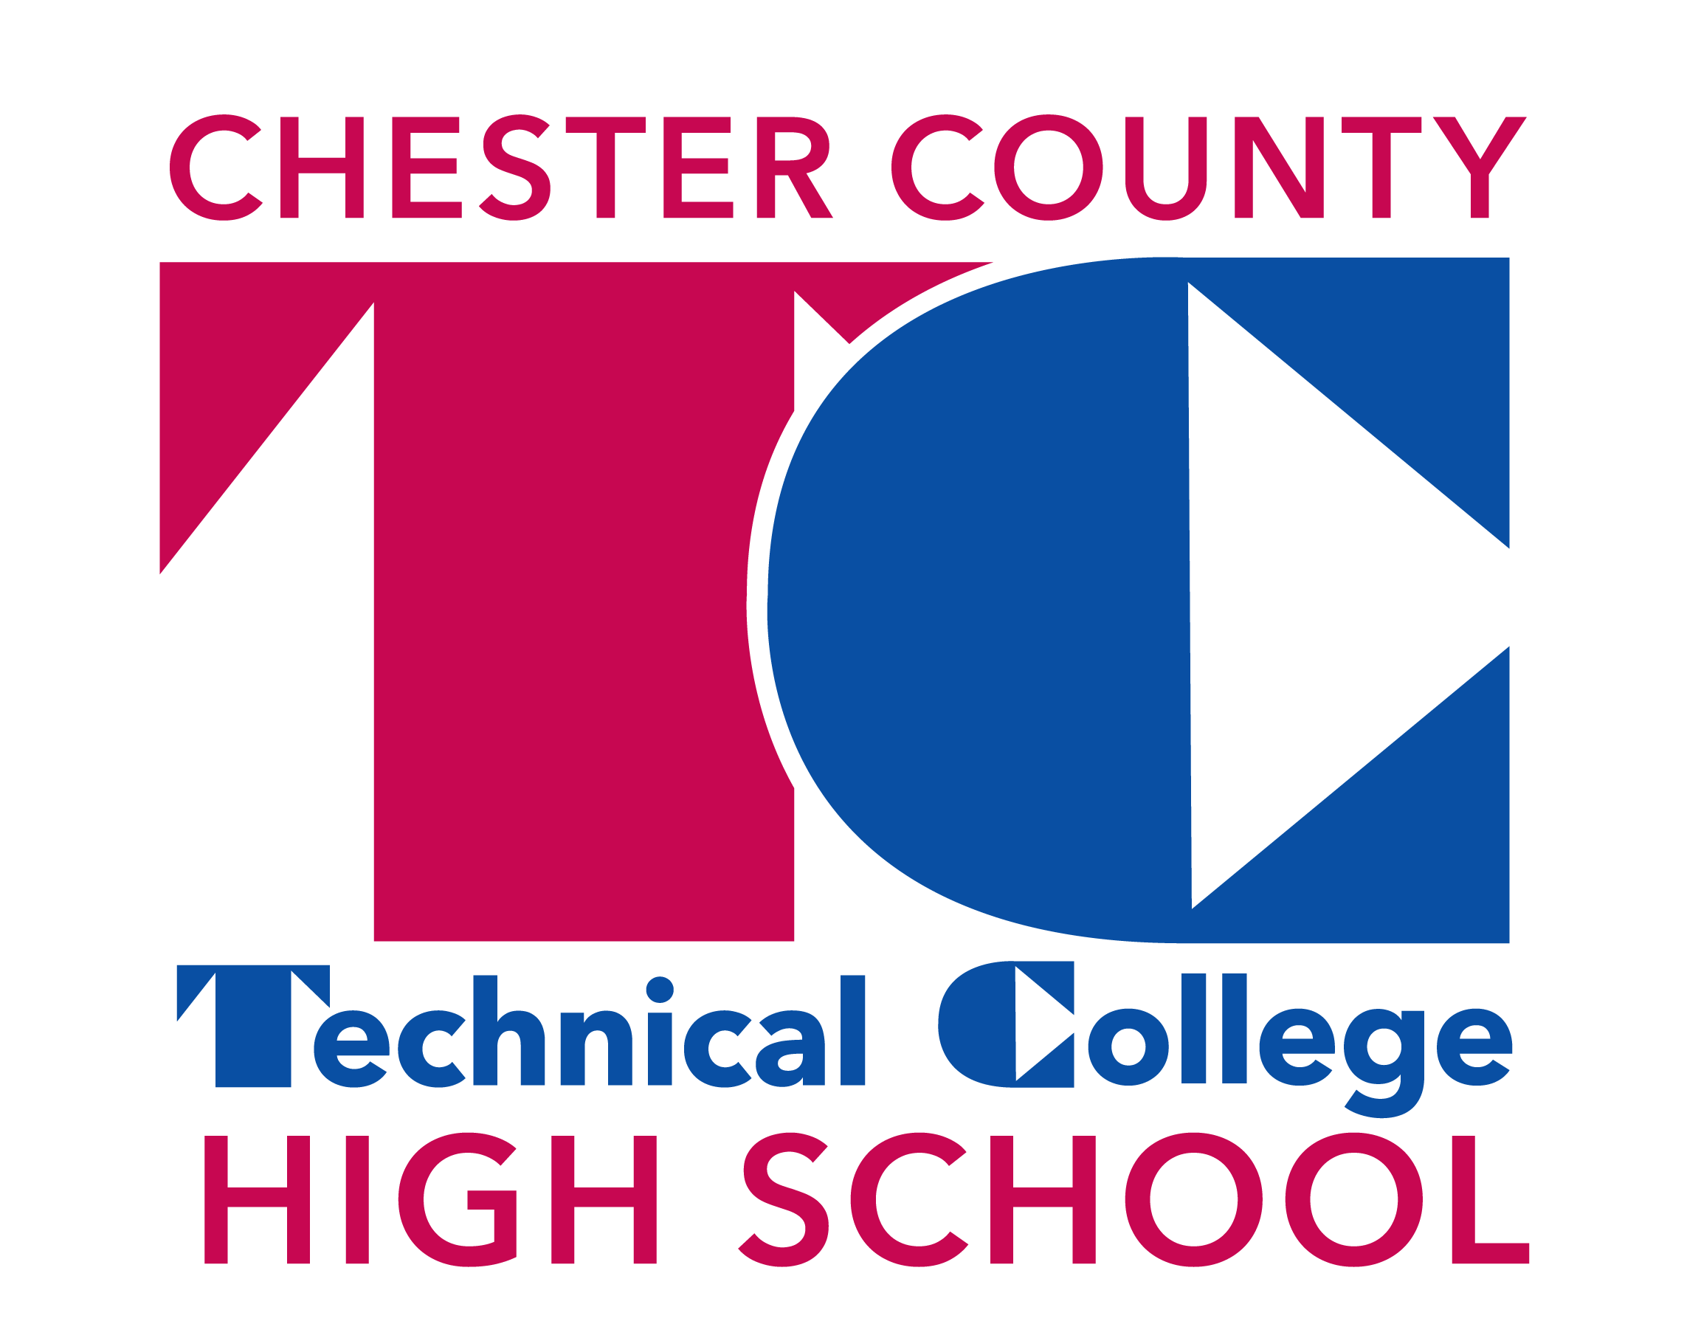
Technical College High School
Pennock’s Bridge Campus
280 Pennock’s Bridge Road, West Grove, PA 19390

4th Annual
College & Career Fair
Tuesday, November 1, 2016 – 6:00 to 8:00 PM
Some Participating Institutions include:
Mansfield University
Massachusetts College of Liberal Arts
Ohio Wesleyan College
Pennsylvania College of Art & Design
Rosemont College
Thaddeus Stevens College of Technology
The Culinary Institute of America
The Restaurant School at Walnut Hill College
United States Air Force
United States Army and Army Reserves
Universal Technical Institute
University of Delaware
University of Louisville
University of North Carolina at Charlotte
University of Pittsburgh-Titusville
University of Valley Forge
Ursinus College
Wells Fargo
West Chester University
Widener University
Wilmington University

Antonelli Institute
Bryn Athyn College
Cecil College
Clarion University
Cottey College
Delaware Valley University
Drexel University
Eastern University
FIDM/Fashion Institute of Design & Merchandising
Goldy-Beacom College
Harcum College
Illinois Institute of Technology
Immaculata University
Ithaca College
King's College
Kutztown University
La Salle University
Lackawanna College
Lincoln University
Main Line Models and Talent

And More!
Please contact TCHS-PB School Counseling Department at 610-345-1800 for questions

